Introduction-LibraTech

- Why we chose this area
We chose the area of library seat management because it directly impacts students’ productivity and study efficiency. many students waste valuable time searching for seats, especially during in peak hours and exam season. this constant struggle also leads to frustration, stress, and loss of focus. our goal was to address this real and relatable problem through a smart, affordable, user friendly digital solution. By combining latest technology with everyday student needs, we aim to create a seamless library experience. Thus, we developed Libra-Tech, an intelligent app that helps students locate available seats in real-time and access digital textbooks effortlessly.
- What are the problems in this area

Problems and Solutions for Library Seat Management
  - Students spend 30-45 minutes finding available seats
Solution:
Our app, Libra-Tech, offers real-time seat availability updates. The interactive map displays the exact location of available and occupied seats. Students can see which areas have free seats and directly navigate to those spots, reducing time spent searching for a place to sit.
  - No way to know library crowd levels before visiting
Solution:
Libra-Tech includes a Live Occupancy Counter on the home screen, showing the current number of students in the library and how many seats are available. This allows students to assess the library's crowd level in real-time before making the trip.
  - Difficult to find seats for group studies
Solution:
The app has a Group Study Filter, which lets students search for available seats where a specific number of adjacent seats are free. This makes it easy to find space for group study sessions, avoiding the frustration of searching for a table large enough for everyone.
  - Wasted time reduces study efficiency
Solution:
By displaying real-time seat availability and reducing the time students spend searching for seats, Libra-Tech helps students maximize their study time and improve their productivity. The app's streamlined check-in and check-out process ensures seats are used efficiently, and students can focus on their studies without interruptions.
  - Lack of a centralized platform for digital textbook access
Solution:
Libra-Tech integrates a Digital Textbook Hub, providing students with quick access to a directory of course materials, e-books, and online resources. The app helps students locate the textbooks they need without having to browse through multiple websites, making study materials more accessible.

General Idea of Our App:
Libra-Tech is a mobile app designed to streamline the student library experience by providing real-time seat availability, a group study filter, and instant access to digital textbooks. It uses a simple, community-powered system where students check in and check out via QR codes to update seat status. The app features an interactive map to help students easily locate available seats and a digital textbook hub for quick access to study materials. By combining seat management and textbook access into a single app, Libra-Tech saves time, reduces stress, and enhances productivity for students

- Secondary survey / Primary survey
We conducted both primary and secondary surveys. In the primary survey, we interviewed 20 students across different departments and found that 70% faced difficulty in finding seats regularly. Our secondary survey included online forums and student feedback pages, which confirmed similar issues across various universities. Both surveys showed a clear need for a reliable, real-time seat availability system.

Part 1: Earlier Studies (2011–2018)
- Crowd sourcing, citizen sensing and sensor web technologies
CITE: International Journal of Health Geographics, 2011
URL: https://ij-healthgeographics.biomedcentral.com/articles/10.1186/1476-072X-10-67
- Crowd sourced mobile data collection: lessons learned
CITE: ResearchGate, 2016
URL: https://www.researchgate.net/publication/262216308_Crowdsourced_mobile_data_collection_lessons_learned_from_a_new_study_methodology
- Precount — Predictive model for correcting real-time counts
CITE: Energy Informatics, SpringerOpen, 2018
URL: https://energyinformatics.springeropen.com/articles/10.1186/s42162-018-0016-4

Part 2: Middle-Phase Studies (2020–2022)
- Seat — Occupancy Monitoring Application for University Library (UC Berkeley project)
CITE: UC Berkeley, School of Information, 2020
URL: https://www.ischool.berkeley.edu/sites/default/files/sproject_attachments/seeat_final_report.pdf
- IoT-Based Smart Library Seat Occupancy and Reservation
CITE: ACM Proceedings, 2021
URL: https://dl.acm.org/doi/10.1145/3487923.3487933
- AFOROS: Low-Cost Wi‑Fi Based Monitoring System
CITE: Sensors Journal, PMC, 2021
URL: https://www.ncbi.nlm.nih.gov/pmc/articles/PMC8199860/
- Development of an Innovative Seat Reservation System (MDPI — BIM integration)
CITE: Buildings, MDPI, 2022
URL: https://www.mdpi.com/2075-5309/12/11/1786
- Passive Wi‑Fi for Community Crowd Sensing
CITE: Sensors, PMC, 2022
URL: https://www.ncbi.nlm.nih.gov/pmc/articles/PMC9844951/
- Longitudinal Study — Thermal Imaging Analysis for Occupancy
CITE: ResearchGate, 2022
URL: https://www.researchgate.net/publication/365811591_A_longitudinal_study_of_the_occupancy_patterns_of_a_university_library_building_using_thermal_imaging_analysis
- Improved IoT-Based System for Detecting Number of People
CITE: Sensors, MDPI, 2022
URL: https://www.mdpi.com/1424-8220/22/20/7912
- Crowd sourcing-based Indoor Map Learning (Survey)
CITE: Smart Cities Journal, Elsevier, 2022
URL: https://www.sciencedirect.com/science/article/pii/S2666720722000583
- Library seat and book availability checking using QR (Undergrad FYP)
CITE: UTAR, Final Year Project Report, 2022
URL: https://eprints.utar.edu.my/4644/1/fyp_CS_2022_CJM.pdf

Part 3: Recent Studies (2023 and beyond)
- Serial Dual-Channel Library Occupancy Detection — Faster R‑CNN
CITE: arXiv preprint, 2023
URL: https://arxiv.org/abs/2306.16080
- Edge-Based Real-Time Occupancy Detection
CITE: Energies, MDPI, 2023
URL: https://www.mdpi.com/1996-1073/16/5/2388
- Privacy-aware Publication of Wi‑Fi Sensor Data
CITE: ACM Digital Library, 2023
URL: https://dl.acm.org/doi/10.1145/3615889.3628513

- What are the unsolved problems

1. No Live Data on Seat Availability
Solution:
Libra-Tech provides real-time seat availability updates using an interactive digital map. This map is powered by a community-driven QR check-in/check-out system. Each seat is shown as a dot: green for available, red for occupied. When a student scans the QR code upon arrival, the map updates instantly for all users, providing accurate and live data at all times.

2. No Integrated System for Both Seat Finding and Textbook Access
Solution:
Libra-Tech combines two essential student needs in one app: seat management and digital resource access. Alongside the real-time seat map, the app includes a Digital Textbook Hub that offers quick access to e-books and course materials, categorized by course code or subject. This integration makes it a single, centralized platform for academic efficiency.

3. Existing Manual Systems Are Inefficient and Outdated
Solution:
Manual systems like paper logs or whiteboard sign-ins are prone to errors and delays. Libra-Tech eliminates this by implementing a QR-based check-in/check-out system and cloud-based database synchronization. This modern approach ensures that seat information is always accurate, reliable, and available in real time with minimal infrastructure cost.

4. Limited Awareness of Current Library Occupancy
Solution:
Libra-Tech features a Live Occupancy Counter on the home screen, displaying the number of students currently in the library and the number of available seats. This visibility helps students decide whether it's the right time to visit the library, especially during high-demand periods such as exams or project deadlines.

- Solution given by you
Our proposed solution is Libra-Tech, a real-time library management mobile app. The app uses QR-based check-in and check-out to update seat availability dynamically. It displays an interactive map of the library showing free and occupied seats, and includes a group study filter for finding multiple adjacent seats. additionally, the app offers a digital textbook hub for quick access to e-books and resources. Libra-Tech is low-cost, easy to implement, and significantly improves the student study experience.

Library Management and Smart Tracking System

1. Live Occupancy Counter Algorithm
Purpose: Display the number of students currently in the library and available seats.
Algorithm:
def update_occupancy(library_id):
total_seats = get_total_seats(library_id)
occupied_seats = count_checked_in_users(library_id)
available_seats = total_seats - occupied_seats
return {"occupied": occupied_seats, "available": available_seats}

- get_total_seats() fetches total seats from the database.
- count_checked_in_users() counts users currently checked in.

2. Interactive Library Map Algorithm
Purpose: Show seat status (available/occupied) in real time.
Algorithm:
def generate_seat_map(library_id):
seats = get_all_seats(library_id)
map_data = []
for seat in seats:
status = "green" if seat.is_available else "red"
map_data.append({"seat_id": seat.id, "x": seat.x, "y": seat.y, "status": status})
return map_data

- Each seat has coordinates (x, y) and a status flag.
- The map is rendered dynamically using this data.

3. Smart Check-In/Check-Out Algorithm
Purpose: Update seat status when a student enters or leaves.
Check-In:
def check_in(user_id, seat_id):
if is_seat_available(seat_id):
mark_seat_occupied(seat_id)
log_check_in(user_id, seat_id)
broadcast_update(seat_id, "occupied")
return True
return False

Check-Out:
def check_out(user_id):
seat_id = get_user_seat(user_id)
mark_seat_available(seat_id)
log_check_out(user_id)
broadcast_update(seat_id, "available")

- broadcast_update() sends real-time updates via WebSocket or push notifications.

4. Group Study Filter Algorithm
Purpose: Find clusters of adjacent available seats.
Algorithm:
def find_group_seats(library_id, group_size):
seat_clusters = get_adjacent_seat_clusters(library_id)
for cluster in seat_clusters:
if all(seat.is_available for seat in cluster) and len(cluster) >= group_size:
return cluster[:group_size]
return []

- get_adjacent_seat_clusters() returns precomputed clusters based on proximity.

5. Digital Textbook Hub Search Algorithm
Purpose: Search and retrieve course materials by subject or course code.
Algorithm:
def search_textbooks(query):
results = []
for book in textbook_database:
if query.lower() in book.title.lower() or query.lower() in book.course_code.lower():
results.append(book)
return results

- Optimized with full-text search or indexing for large datasets.

6. Real-Time Sync Algorithm (Community-Powered System)
Purpose: Sync seat status across all devices instantly.
Algorithm:
def broadcast_update(seat_id, status):
update_database(seat_id, status)
notify_all_users({"seat_id": seat_id, "status": status})

- Uses cloud database + push notifications or WebSocket for real-time synchronization.

Data Flow Diagrams

Level 0 DFD – Context Diagram
This diagram represents the system as a single unit interacting with external entities.
+------------------+ +------------------+ +------------------+
| | | | | |
| Student User +-------->+ The App +<--------+ Library Admin |
| | | | | |
+------------------+ +------------------+ +------------------+
|
v
+------------------+
| Cloud Database |
+------------------+

Level 1 DFD – Major Components
This diagram shows the main subsystems of the app.
+------------------+ +------------------+ +------------------+
| | | | | |
| Student User +-------->+ Mobile Interface+-------->+ Seat Tracker |
| | | | | & QR System |
+--------+---------+ +--------+---------+ +--------+---------+
| | |
| v |
| +------------------+ +--------+---------+
| | | | |
+----------------->+ Textbook Search +<--------+ Library Admin |
| Engine | | |
+------------------+ +------------------+
|
v
+------------------+
| Cloud Database |
+------------------+

Level 2 DFD – Internal Modules

1. Seat Tracker & QR System
+------------------+
| QR Code Scanner |
+--------+---------+
|
v
+--------+---------+ +------------------+
| Check-In Logic +-------->+ Seat Allocator |
+--------+---------+ +--------+---------+
| |
v v
+--------+---------+ +------------------+
| Check-Out Logic +-------->+ Map Updater |
+------------------+ +------------------+

2. Textbook Search Engine
+------------------+
| Search Bar UI |
+--------+---------+
|
v
+--------+---------+ +------------------+
| Query Processor +-------->+ Course Mapper |
+--------+---------+ +--------+---------+
| |
v v
+--------+---------+ +------------------+
| Result Formatter+-------->+ Link Retriever |
+------------------+ +------------------+

Data Stores
- Cloud Database:
  - Stores seat occupancy data.
  - Stores check-in/out logs.
  - Stores library layout and map.
  - Stores textbook metadata and links.

Architecture
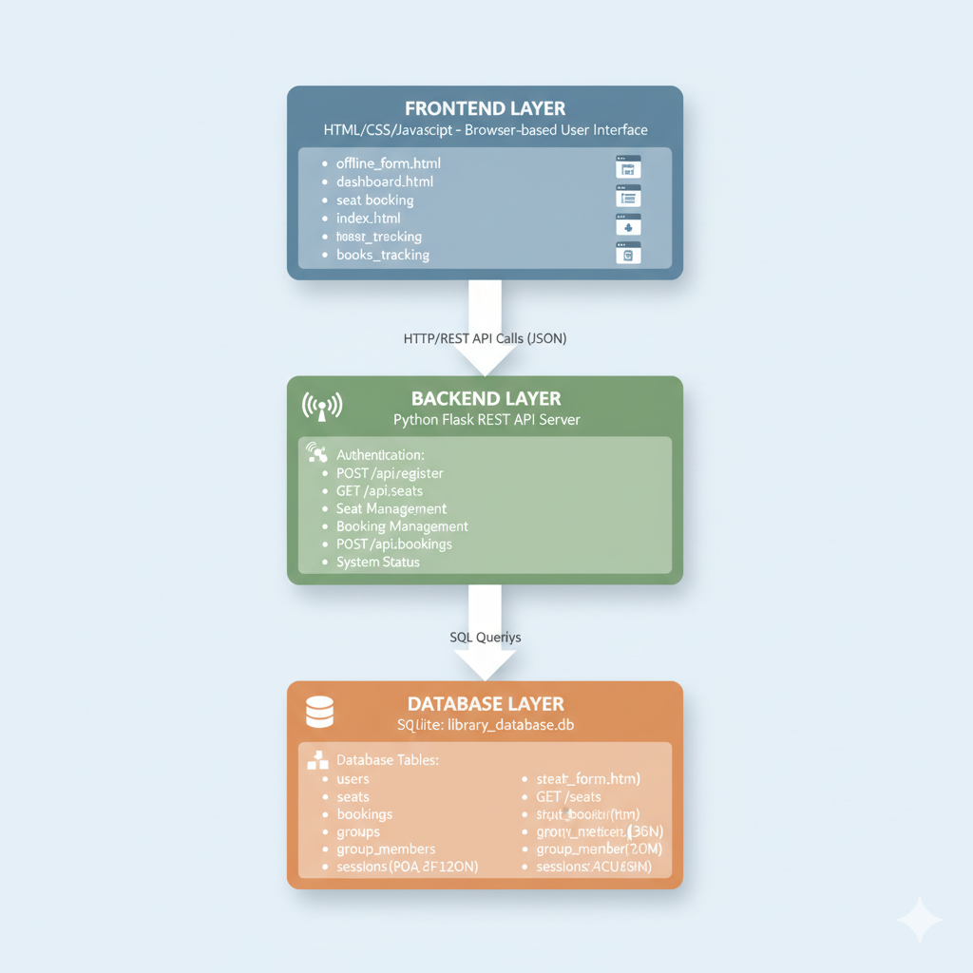

Application Workflow

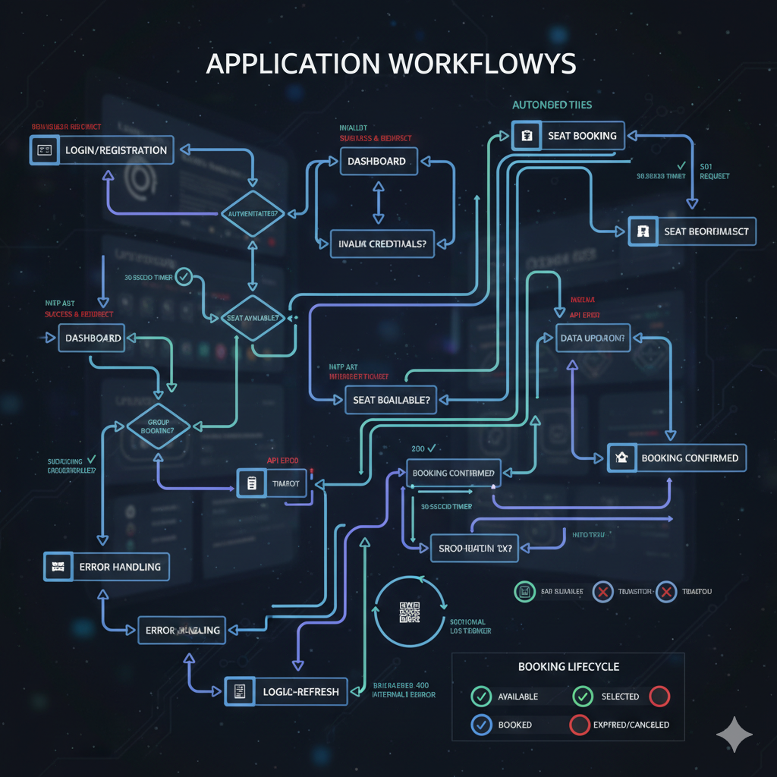

File Structure
